Simple 3-Tier Architecture (Beginner Friendly Notes)

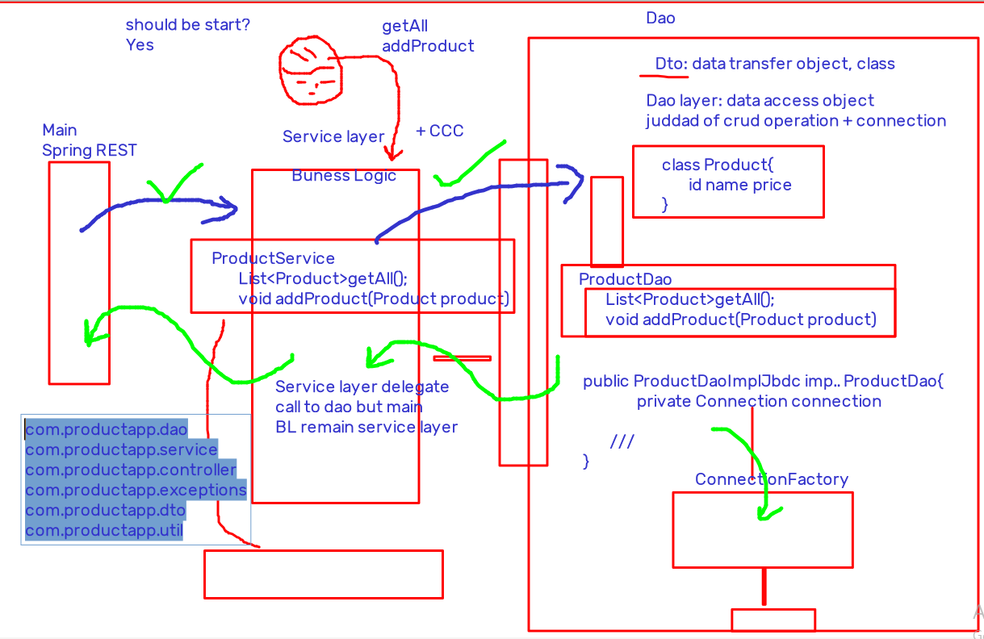

What is 3-Tier Architecture?
Think restaurant model:
- Controller → Waiter (takes request)
- Service → Brain / Manager (decides what to do)
- DAO → Kitchen (talks to database)
Each layer has one job only.
If layers mix responsibilities, maintenance becomes a horror movie.

Step 1: Directory / Package Structure
com.productapp.dao
com.productapp.service
com.productapp.controller
com.productapp.exceptions
com.productapp.dto
com.productapp.util

Why this structure?
- dao → database logic
- service → business rules + coordination
- controller → entry point (REST / main / UI)
- dto → data carrier objects
- exceptions → custom errors (future)
- util → helpers (connection factory, etc.)

Step 2: Start from DAO Layer (Bottom-Up Approach)

Why start from DAO?
Because data comes first.
No data → no business → no API → only PowerPoint slides.

Step 2.1: Create DTO (Data Transfer Object)
DTO is like a thali 🍱
Food moves from Kitchen (DB) to Dining Table (Service / Controller) using a thali.
public class Product {
private int id;
private String name;
private double price;
// assume all methods
}

DTO Rules
- No business logic
- Only fields + getters/setters
- Serializable if needed later

Step 2.2: Create DAO Interface
Interface = contract
Implementation can change, contract should not.
public interface ProductDao {
List<Product> getAll();
void addProduct(Product product);
}

Why interface?
- Today → JDBC
- Tomorrow → JPA / Hibernate
- Service layer stays calm and happy

Step 2.3: DAO Implementation Using JDBC
(Tomorrow this will be replaced with JPA — students relax)
public class ProductDaoImplJdbc implements ProductDao {

private Connection connection;

public ProductDaoImplJdbc() {
connection = ConnectionFactory.getConnection();
}

@Override
public List<Product> getAll() {
List<Product> products = new ArrayList<>();
try {
Statement stmt = connection.createStatement();
ResultSet rs = stmt.executeQuery("select * from product");
while (rs.next()) {
products.add(
new Product(
rs.getInt(1),
rs.getString(2),
rs.getDouble(3)
)
);
}
} catch (SQLException e) {
e.printStackTrace();
}
return products;
}

@Override
public void addProduct(Product product) {
try {
PreparedStatement pstmt =
connection.prepareStatement(
"insert into product(name,price) values (?,?)"
);
pstmt.setString(1, product.getName());
pstmt.setDouble(2, product.getPrice());
pstmt.executeUpdate();
} catch (SQLException e) {
e.printStackTrace();
}
}
}

DAO Responsibilities
- SQL
- ResultSet handling
- No validation
- No timing logic
- No business rules

Step 2.4: Connection Factory (Utility Layer)
⚠️ Not production-ready
Single connection = poor performance
Later → Connection Pool (HikariCP, DBCP)
public class ConnectionFactory {

private static Connection connection;
static String driver;
static String url;
static String username;
static String password;

public static Connection getConnection() {
InputStream is = null;
Properties properties = new Properties();
try {
is = new FileInputStream("db.properties");
properties.load(is);

driver = properties.getProperty("jdbc.driver");
url = properties.getProperty("jdbc.url");
username = properties.getProperty("jdbc.username");
password = properties.getProperty("jdbc.password");

} catch (FileNotFoundException | IOException e) {
e.printStackTrace();
}

try {
Class.forName(driver);
connection = DriverManager.getConnection(
url, username, password
);
} catch (ClassNotFoundException | SQLException e) {
e.printStackTrace();
}
return connection;
}
}

db.properties
jdbc.driver=com.mysql.jdbc.Driver
jdbc.url=jdbc:mysql://localhost:3306/ymsli26?useSSL=false
jdbc.username=root
jdbc.password=root

Step 3: Service Layer (Brain of the Application)
Service Layer =
BL (Business Logic) + CCC (Cross-Cutting Concerns)
Examples of CCC:
- Logging
- Timing
- Validation
- Transactions
- Security

Step 3.1: Service Interface
public interface ProductService {
List<Product> getAll();
void addProduct(Product product);
}

Step 3.2: Service Implementation
public class ProductServiceImpl implements ProductService {

private ProductDao productDao;
private ProductValidation productValidation;

public ProductServiceImpl() {
productDao = new ProductDaoImplJdbc();
productValidation = new ProductValidationImpl();
}

@Override
public List<Product> getAll() {
long start = System.currentTimeMillis();
List<Product> products = productDao.getAll();
long end = System.currentTimeMillis();
System.out.println(
"time taken is : " + (end - start) + " ms"
);
return products;
}

@Override
public void addProduct(Product product) {
if (productValidation.isValid(product)) {
productDao.addProduct(product);
}
}
}

Key Rule
Service delegates to DAO,
but decision-making stays in Service.
DAO is dumb. Service is smart.

Step 3.3: Validation Layer

Validation Interface
public interface ProductValidation {
boolean isValid(Product product);
}

Validation Implementation
public class ProductValidationImpl
implements ProductValidation {

@Override
public boolean isValid(Product product) {
// regex in java (to be learned)
return true;
}
}

Step 4: Controller / Test Layer
Currently using main method
Later → Spring REST Controller
public class ProductController {

public static void main(String[] args) {

ProductService productService =
new ProductServiceImpl();

List<Product> products =
productService.getAll();

products.forEach(
p -> System.out.println(p)
);
}
}

Database Reminder
Before running:
- Create database
- Create product table
- Insert sample data
No DB = No output = Confused students

